* **What is Box Model**CSS box model is a container which contains multiple properties including borders, margin, padding and the content itself. It is used to create the design and layout of web pages. It can be used as a toolkit for customizing the layout of different elements.

div {

background-color: lightgrey;

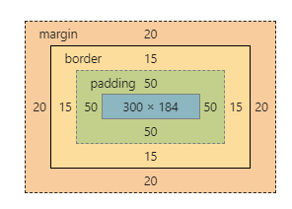

width: 300px;

border: 15px solid green;

padding: 50px;

margin: 20px;

/* box-sizing: border-box; */

}

* Content - The content of the box, where text and images appear
* Padding - Clears an area around the content. The padding is transparent
* Border - A border that goes around the padding and content
* Margin - Clears an area outside the border. The margin is transparent

Total element width = width + left padding + right padding + left border + right border + left margin + right margin

The total height of an element should be calculated like this:

Total element height = height + top padding + bottom padding + top border + bottom border + top margin + bottom margin

**What is Specificity?**

If there are two or more conflicting CSS rules that point to the same element, the browser follows some rules to determine which one is most specific and therefore wins out.

The universal selector (*) has low specificity, while ID selectors are highly specific!

**!important vs .el.el method for specificity**

We can also use double or triple class name in css so it will increase the specificity.  
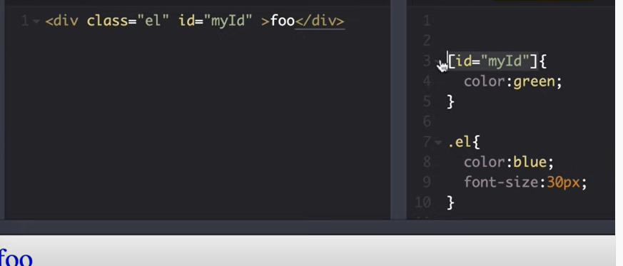 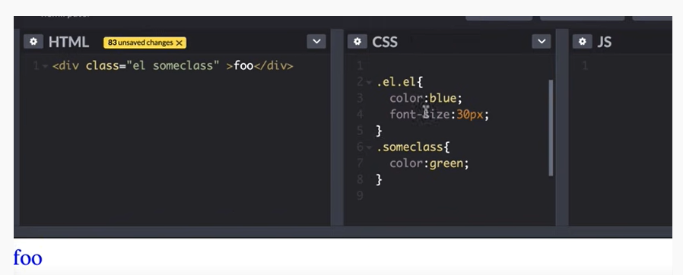

**How to show center of one block element into another block element ?**

**What is shadow dom in css**

**What is position Property**The position property specifies the type of positioning method used for an element (static, relative, fixed, absolute or sticky).

* **Static :** HTML elements are positioned static by default.
* **Relative :** An element with position: relative; is positioned relative to its normal position.but we can set top, bottom, left, right
* **Fixed :** it always stays in the same place even if the page is scrolled. The top, right, bottom, and left properties are used to position the element.
* **Absolute :** An element with position: absolute; is positioned relative to the nearest positioned ancestor (instead of positioned relative to the viewport, like fixed).  
  However; if an absolute positioned element has no positioned ancestors, it uses the document body, and moves along with page scrolling.
* **Sticky :** An element with position: sticky; is positioned based on the user's scroll position.

**visibility hidden and display none :**

display:none means that the tag in question will not appear on the page at all (although you can still interact with it through the dom). There will be no space allocated for it between the other tags. visibility:hidden means that unlike display:none , the tag is not visible, but space is allocated for it on the page.

**What are psudo :: element and psudo : class ?**A pseudo-class is used to define a special state of an element.

Style an element when a user mouses over it

Style visited and unvisited links differently

Style an element when it gets focus  
a:hover {  
  color: #FF00FF;  
}

A CSS pseudo-element is used to style specified parts of an element.

For example, it can be used to:

Style the first letter, or line, of an element

Insert content before, or after, the content of an element  
p::first-line {  
  color: #ff0000;  
  font-variant: small-caps;  
}

p::first-letter {

color: #ff0000;

font-size: xx-large;

}  
**Diffenreces :**

Basically a **pseudo-class** is a selector that assists in the selection of something that cannot be expressed by a simple selector

**Pseudo-elements** effectively create new elements that are not specified in the markup of the document and can be manipulated much like a regular element

**Data Attributes in css**

<span data-tooltip="A simple explanation">Word</span>

You can use data attributes in CSS to style elements using attribute selectors. You can also show the information stored in the data attribute to users (in a tooltip or some other way) with the help of the attr() function.

span.tooltip::before {

content: attr(data-tooltip);

position: absolute;

top: 1.5em;

font-size: 0.9em;

padding: 1px 5px;

display: none;

color: white;

background: rgba(0, 0, 0, 0.75);

border-radius: 4px;

transition: opacity 0.1s ease-out;

z-index: 99;

text-align: left;

}

**How can I create a given in pure css**

<div class="tri"></div>

.tri{

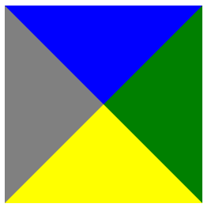

height:0px;

width:0px;

background-color:red;

border-top:100px solid blue;

border-bottom:100px solid yellow;

border-left:100px solid white;

border-right:100px solid green;

}

**How to create given design**

.tri{

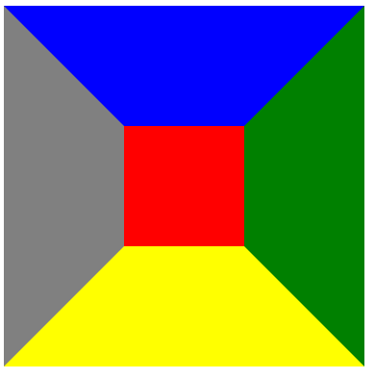

height:100px;

width:100px;

background-color:red;

border-top:100px solid blue;

border-bottom:100px solid yellow;

border-left:100px solid gray;

border-right:100px solid green;

}

How to create triangle

.tri{



width: 0;

height: 0;

border-left: 10px solid transparent;

border-right: 10px solid transparent;

border-bottom: 10px solid black;

}

.tri{

width: 0;



height: 0;

border-left: 10px solid transparent;

border-right: 10px solid transparent;

border-top: 10px solid black;

}

1. **How to show image in center of div**

img {

width: 80%;

position: absolute;

top: 50%;

left: 50%;

transform: translate(-50%, -50%);

}

div {

height: 800px;

position: relative;

background: red;

}

**How to show a image center in a div using flex.**

display: flex;

justify-content: center; /* align horizontal */

align-items: center; /* align vertical */

1. Html ARIA :   
   WAI-ARIA stands for “Web Accessibility Initiative – Accessible Rich Internet Applications”. It is a set of attributes to help enhance the semantics of a web site or web application to help assistive technologies, such as screen readers for the blind, make sense of certain things that are not native to HTML. The information exposed can range from something as simple as telling a screen reader that activating a link or button just showed or hid more items, to widgets as complex as whole menu systems or hierarchical tree views.
2. How to add css file in html  
   <link rel="stylesheet" type="text/css" href="mystyles.css" />
3. What is a CSS Preprocessor? What are Sass, Less, and Stylus? Why do people use them?  
   A CSS Preprocessor is a tool used to extend the basic functionality of default vanilla CSS through its own scripting language. It helps us to use complex logical syntax like – variables, functions, mixins, code nesting, and inheritance to name a few, supercharging your vanilla CSS.
4. Differences between preprocessor  
   SASS uses .sass extension while SCSS uses .scss extension.

SASS doesn’t use curly brackets or semicolons. SCSS uses it, just like the CSS.  
SASS Syntax

$font-color: #fff

$bg-color: #00f

#box

color: $font-color

background: $bg-color

SCSS Syntax

$font-color: #fff;

$bg-color: #00f;

#box{

color: $font-color;

background: $bg-color;

}

LESS: LESS is an acronym for “Leaner Stylesheets”. LESS is easy to add to any javascript projects by using NPM or less.js file. It uses the extension .less.

LESS syntax is the same as the SCSS with some exceptions. LESS uses @ to define the variables.

@font-color: #fff;

@bg-color: #00f

#box{

color: @font-color;

background: @bg-color;

}

1. What is **box-sizing**The box-sizing property allows us to include the padding and border in an element's total width and height.

… without adding box-sizing. If we fix height and width it looks like some bigger in size after adding the padding

1. What is Z-index  
   The z-index property specifies the stack order of an element (which element should be placed in front of, or behind, the others)  
   z-index only works on [positioned elements](https://www.w3schools.com/css/css_positioning.asp) (position: absolute, position: relative, position: fixed, or position: sticky) and [flex items](https://www.w3schools.com/css/css3_flexbox.asp) (elements that are direct children of display: flex elements).
2. What is overflow in css

The overflow property specifies whether to clip the content or to add scrollbars when the content of an element is too big to fit in the specified area.

The overflow property has the following values:

visible - Default. The overflow is not clipped. The content renders outside the element's box

hidden - The overflow is clipped, and the rest of the content will be invisible

scroll - The overflow is clipped, and a scrollbar is added to see the rest of the content

auto - Similar to scroll, but it adds scrollbars only when necessary

1. What is clear property

When we use the float property, and we want the next element below (not on right or left), we will have to use the clear property.

The clear property specifies what should happen with the element that is next to a floating element.

The clear property can have one of the following values:

none - The element is not pushed below left or right floated elements. This is default

left - The element is pushed below left floated elements

right - The element is pushed below right floated elements

both - The element is pushed below both left and right floated elements

inherit - The element inherits the clear value from its parent

1. What is Clearfix  
   The Clearfix: Force an Element To Self-Clear its Children.

If a floated element is taller than the containing element, it will "overflow" outside of its container. We can then add a clearfix hack to solve this problem  
.img2 {

float: right;

}

.clearfix::after {

content: "";

clear: both;

display: table;

}

<div class="clearfix">

<img class="img2" src="pineapple.jpg" alt="Pineapple" width="170" height="170">

Lorem ipsum dolor sit amet, consectetur adipiscing elit. Phasellus imperdiet...

</div>

### 42. Difference between SVG and Canvas HTML5 element?

| **SVG** | **Canvas** |
| --- | --- |
| SVG is a vector based i.e., composed of shapes. | It is Raster based i.e., composed of pixels. |
| SVG works better with a larger surface. | Canvas works better with a smaller surface. |
| SVG can be modified using CSS and scripts. | Canvas can only be modified using scripts. |
| SVG is highly scalable. So we can print at high quality with high resolution. | It is less scalable. |

Compared to display: inline, the major difference is that display: inline-block allows to set a width and height on the element.

Also, with display: inline-block, the top and bottom margins/paddings are respected, but with display: inline they are not.

Html tag and elements  
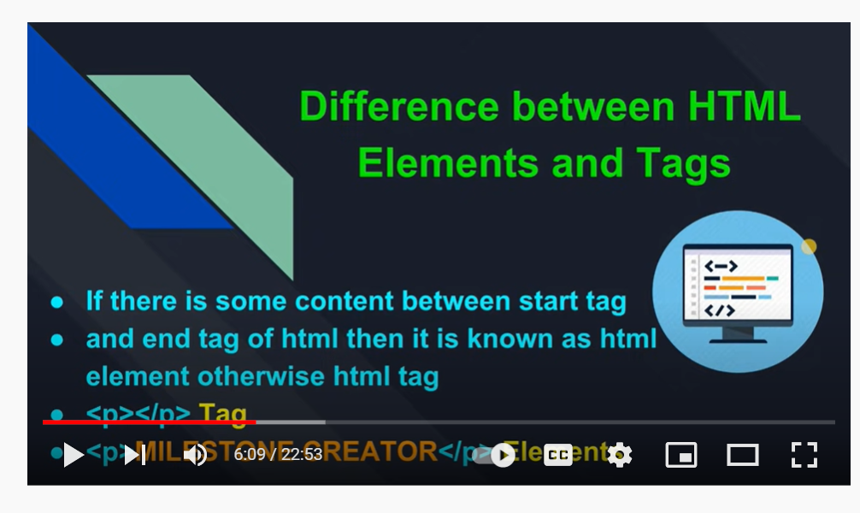

Different between css and css3

|  |  |
| --- | --- |
| Responsive designing is not supported in CSS | CSS3 is the latest version, hence it supports responsive design. |
| CSS cannot be split into modules. | Whereas, CSS3 can be breakdown into modules. |
| Using CSS, we cannot build 3D animation and transformation. | But in CSS3 we can perform |
| CSS does not support media queries. | But CSS3 supports media queries |